RETAIL ORDERS ETL PIPELINE USING POWER QUERY
Business Requirement
The Human Resources department requires a clean, standardized, and analysis-ready employee dataset to generate business insights related to employee attrition, workforce demographics, salary distribution, job satisfaction, and departmental performance. The source dataset contains raw employee records which must be validated, profiled, cleaned, and transformed before being used for reporting and dashboard creation in Power BI. The objective of this project is to design a complete ETL pipeline using Power Query by following industry-standard data preparation practices.
Data Understanding
Attribute | Value
Dataset Name | IBM HR Analytics Employee Attrition & Performance
Business Domain | Human Resources (HR Analytics)
Source | Kaggle (IBM HR Analytics Employee Attrition & Performance Dataset)
File Format | Microsoft Excel Workbook (.xlsx)
Number of Records (Rows) | 1,470
Number of Columns | 35
Primary Tool Used | Power BI – Power Query
Project Type | ETL (Extract, Transform, Load) Pipeline

The dataset contains employee demographic, compensation, job role, performance, and attrition-related information. It will be used to build an ETL pipeline in Power Query and later develop an HR Analytics dashboard in Power BI.
Data Profiling
What is Data Profiling?
Data profiling is the process of examining raw data to understand its quality before any transformation is performed. Power Query provides three profiling tools:
- Column Quality: Checks for valid values, empty values, and errors
- Column Distribution: Shows unique values and duplicates
- Column Profile: Provides statistics like minimum, maximum, average, and count
- Record count
We will verify:
- Duplicate records
- Missing values
- Data types
- Blank rows
- Invalid values
- Formatting inconsistencies
Step 1: Check the Dataset Shape
Objective : Understand the size of the dataset before starting ETL.
Observation :
Number of Rows: Number of Columns:
Business Importance : Knowing the size of the dataset helps estimate transformation complexity and validate that no records are unintentionally lost during the ETL process.
Step 2: Verify Column Names
Observation : The dataset contains descriptive and business-friendly column names. No renaming is required.
Step 3: Check Data Types
Go through every column and verify its data type.
Step 4: Read Column Quality
For each column, Power Query shows:
🟢 Valid
⚫ Empty
🔴 Error
Write down: Do any columns contain empty values?
Do any columns contain errors?
Transformation: Applied Steps
Objective: Track every transformation performed on the dataset.
Why?
Power Query records transformations sequentially, allowing the ETL process to be refreshed and repeated without manual effort.
Business Benefit: Ensures consistency and reduces manual data preparation.
What are Applied Steps in Power Query?
Applied Steps represent the sequence of transformations performed on the dataset. During data refresh, Power Query executes these steps in order, ensuring the same transformations are consistently applied to new or updated data.
Transformation: ETL Pipeline Cleanup
Objective: Remove redundant transformation steps to improve readability and maintainability.
Reason: Duplicate or unnecessary steps increase ETL complexity without adding value.
Business Benefit: A clean ETL pipeline is easier to review, debug, maintain, and hand over to other analysts.

Extract
- Source: Excel Workbook
- Table: IBM HR Analytics Employee Attrition & Performance
- Tool: Power Query Editor
Transform
Step | Transformation | Why? | Business Benefit
1 | Change Data Types | Correct calculations | Accurate reporting
2 | Remove Blank Rows | Delete invalid records | Cleaner data
3 | Remove Duplicates | Avoid duplicate sales | Correct KPIs
4 | Trim Text | Remove spaces | Consistent joins
5 | Clean Text | Remove hidden characters | Standardized values
6 | Rename Columns | Improve readability | Easy reporting
7 | Replace Values | Standardize data | Better analysis
8 | Split Columns | Extract useful information | More detailed analysis
9 | Merge Columns | Create business fields | Reporting convenience
10 | Custom Columns | Business calculations | Additional insights
11 | Conditional Columns | Business rules | Categorization
12 | Date Columns | Year, Month, Quarter | Time analysis
13 | Group By | Summarize data | Aggregation
14 | Merge Queries | Combine datasets | Data enrichment
15 | Append Queries | Combine multiple files | Consolidation

Validation
Validation Checklist
- Data types verified
- Missing values handled – check for the empty% in column quality(if empty=0% -> no missing value)
- Duplicates removed
- Data quality confirmed

Load
- Destination: Power BI
- Purpose: Dashboard Development
Remove Constant Value Columns
Objective: Remove columns containing a single repeated value across all records.
Columns Removed
- EmployeeCount
- Over18
- StandardHours
Business Justification: These columns contain constant values for every employee and do not provide meaningful information for reporting, filtering, segmentation, or business analysis.
Removing them simplifies the dataset and improves data model efficiency.
Expected Outcome : The dataset becomes leaner and easier to analyze without losing any meaningful business information.
Duplicate Record Analysis
Objective: Verify whether duplicate employee records exist using the EmployeeNumber column as the unique identifier.
Why EmployeeNumber?
Every employee should have a unique employee ID. If duplicate IDs exist, they may indicate duplicate records that could distort business metrics.
Observation:
Total Records: 1,470
Distinct Employee Numbers: 1,470
Unique Employee Numbers: 1,470
No duplicate employee records were identified.
Business Justification: Since each employee is uniquely identified by the EmployeeNumber, no duplicate removal is necessary. Removing records without evidence of duplication could lead to data loss.
Outcome: No transformation performed.
Standardize Column Names
Objective: Rename technical column names to improve readability and maintain a consistent naming convention throughout the dataset.
Transformation Performed: Applied Title Case with Spaces naming convention to descriptive columns.
Business Justification: Business-friendly column names improve collaboration between analysts, simplify report development, and make DAX formulas easier to understand and maintain.
Expected Outcome: The dataset becomes easier to interpret while preserving the original business meaning of each field.
Create Age Group
Objective: Create an employee age classification to support demographic analysis.
Transformation Type: Conditional Column
Age Range | Age Group
Less than 30 | Young
30–39 | Mid Career
40–49 | Experienced
50 and above | Senior
Business Justification: Grouping employees into age categories simplifies workforce analysis and enables HR to compare attrition, salary, and satisfaction across different age segments.
Output Column: Age Group
We'll create a new column called Salary Band.
If | Column | Operator | Value | Output
1 | Monthly Income | is less than | 5000 | Low Income
Else If | Monthly Income | is less than | 10000 | Medium Income
Else If | Monthly Income | is less than | 15000 | High Income
Else |  |  |  | Very High Income
This is called feature engineering.
We're transforming a raw numeric field into a business-friendly category that managers can use in reports like:
- Employees by Salary Band
- Attrition by Salary Band
- Average Job Satisfaction by Salary Band
These categories are much easier for business users to understand than hundreds of different salary values.
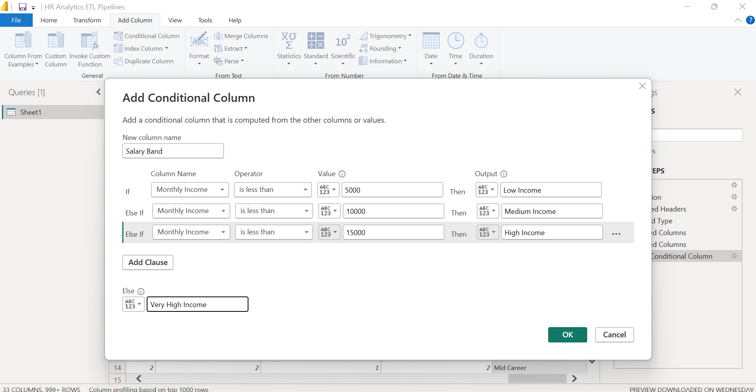
Create Experience Level
Objective: Categorize employees based on their total work experience.
Business Justification: Instead of comparing individual years of experience, HR can quickly analyze workforce distribution, attrition, salary, and promotions across experience categories.
Outcome: A new business-friendly column named Experience Level was created.
Total Working Years | Experience Level
< 3 | Fresher
< 7 | Junior
< 15 | Mid-Level
Otherwise | Senior
Business Rule Validation
Objective: Validate that employees do not have more years at the company than their total working experience.
Years At Company ≤ Total Working Years
Business Justification: This validation ensures logical consistency within the HR dataset and helps identify incorrect or corrupted records before reporting.
Advanced Power Query Features
A Reference creates a new query linked to the original. Changes to the original query flow into the reference. A Duplicate creates an independent copy.
Department Summary Using Group By
Objective: Create an aggregated department-level summary from employee-level data.
Transformation: Applied Group By on the Department column to calculate:
- Employee Count
- Average Monthly Income
- Maximum Monthly Income
- Minimum Monthly Income
Business Justification: Instead of reviewing individual employee records, HR managers often require department-level summaries for workforce planning, salary benchmarking, and budgeting.
Merge Queries
Objective: Combine employee data with department metadata to enrich the dataset.
Source Tables
- Employee Data
- Department Lookup
Join Type: Left Outer Join
Matching Column: Department
Columns Added
- Department Head
- Location
Business Justification: Department information such as manager and office location is maintained separately. Merging the lookup table enriches the employee dataset without duplicating data manually, ensuring consistency and easier maintenance.
Append Queries
Objective: Combine employee records from multiple datasets into a single master table.
Source Tables
- Employee Data - Sales
- Employee Data - R&D
Transformation: Append Queries
- Append Queries → modifies the current query.
- Append Queries as New → creates a brand new query, leaving the original queries unchanged.
Business Justification: Organizations often receive employee records from multiple branches or departments. Appending combines them into a single dataset for reporting and analysis.
Output: A consolidated employee dataset.
Pivot and Unpivot
Pivot Columns :-
Objective: Convert monthly sales records from rows into columns.
Source Columns: Employee
Month
Sales
Pivot Column: Month
Values Column: Sales
Business Justification: Managers often prefer reports with months displayed as columns because they are easier to compare and present in spreadsheets or reports.
Outcome:
Employee | Jan | Feb | Mar
John | 5000 | 6000 | 5500
Sarah | 7000 | 8000 | 7500
Unpivot Columns :-
Objective: Convert month-wise columns into row-wise records.
Source Columns Jan
Feb
Mar
Output Columns Month
Sales
Business Justification: Analytical databases and BI tools work more efficiently with normalized (long-format) data. Unpivoting converts wide tables into a structure suitable for reporting and further transformations.
Outcome: Monthly sales columns were transformed into row-wise records.
Employee | Month | Sales
John | Jan | 5000
John | Feb | 6000
John | Mar | 5500
Sarah | Jan | 7000
Sarah | Feb | 8000
Sarah | Mar | 7500
Trim & Clean
Objective: Standardize text data by removing unnecessary spaces and hidden characters from text fields.
Transformation: Applied Trim to remove leading and trailing spaces.
Applied Clean to remove non-printable and hidden characters.
Business Justification: Data imported from Excel, CSV files, or external systems may contain extra spaces or hidden characters, leading to inconsistent values during filtering, grouping, and merging. Applying Trim and Clean improves data quality and consistency.
Outcome: Text values were standardized, reducing the risk of duplicate or mismatched records caused by formatting inconsistencies.
Replace Values
Objective: Standardize inconsistent data values across the dataset.
Transformation: Used Replace Values to substitute inconsistent or abbreviated values with standardized values.
Business Justification: Replacing inconsistent values improves data consistency and ensures accurate reporting and analysis by preventing multiple representations of the same information.
Outcome: Data values were standardized, making the dataset more reliable for reporting and analysis.
Reference vs Duplicate Queries
Objective: Understand the difference between creating linked queries and independent copies.
Transformation
- Created Reference Queries to derive new datasets while maintaining a connection to the original query.
- Studied Duplicate Queries to understand scenarios where an independent copy is required.
Business Justification: Reference queries reduce duplication, simplify maintenance, and ensure derived datasets remain synchronized with changes made to the source query. Duplicate queries are useful for independent experimentation without affecting the original query.
Outcome: Learned to choose the appropriate approach based on business and ETL requirements.
Close & Apply
Objective: Load the transformed data into the Power BI data model.
Transformation: Executed Close & Apply to apply all Power Query transformations and load the processed data into Power BI.
Business Justification: The transformed dataset becomes available for reporting and visualization while preserving the original source file. Any future data refresh automatically reapplies all transformation steps.
Outcome: Successfully loaded the cleaned and transformed dataset into the Power BI data model, making it ready for reporting and analysis.

